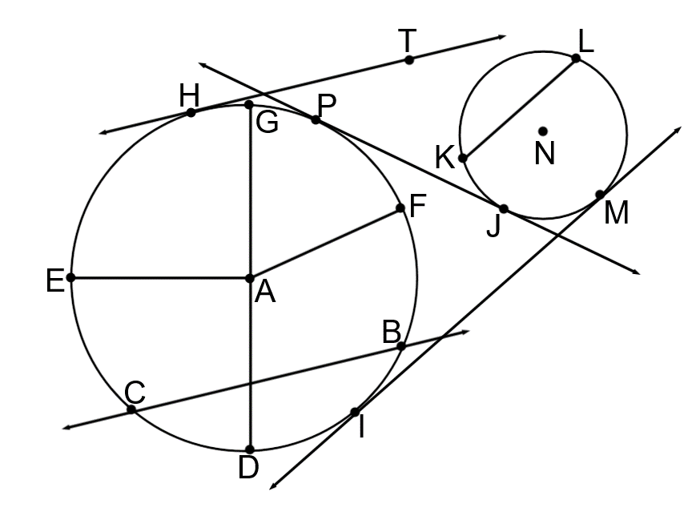
23) Name 3 radii _______________________________________________
24) Name 1 diameter ______________
25) Name 3 chords ____________________________________________
26) Name 1 secant ________________
27) Name 3 tangents __________________________________________
28) Name 2 common tangents __________________________________
29) Name 4 points of tangency __________________________________
30) Name 2 centers _________________
31) Name 4 minor arcs ______________________________________________________
32) Name 2 semicircles _____________________________________________________
33) Name 4 major arcs ______________________________________________________

