Geometry Name _______________________

Unit 3 Review Sheet – Right Triangle Trig

1. Triangle DEF is a right triangle. What is the best approximation for m<C?

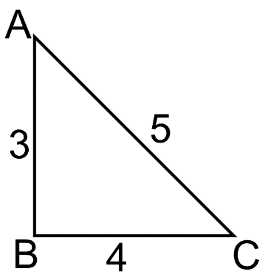

2. What is the definition of the cosine ratio of an acute angle of a triangle?

3. What is the definition of the sine ratio of an acute angle of a triangle?

4. What is the definition of the tangent ratio of an acute angle of a triangle?

5. In the triangle to the right, . Find sin A.

A

C

B

A.  B. 

C.  D. 

6. What is an equivalent trig ratio for tan 28?

7. What is an equivalent trig ratio for tan 49?

8. What is an equivalent trig ratio for sin 60˚?

9. What is an equivalent trig ratio for cos 57˚

.

10. A 15 foot ladder is leaning against a building at a 65˚ angle with the ground. Write an equation that could be used to solve for how high the ladder reaches up the side of the building.

Find the value for each variable. Round all answers to the **nearest hundredth**.

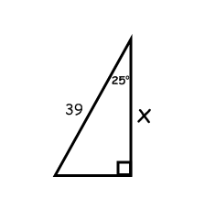

11) x = __________ 12) x = __________

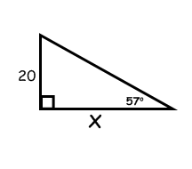

13) x = __________ 14) x = __________

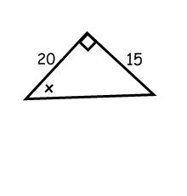

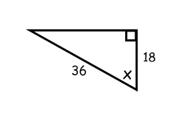

15) x = __________ 16) x = __________

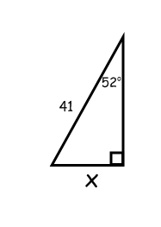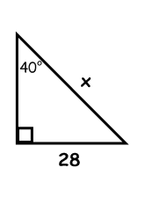

Solve each problem. Round answers to the hundredth place.

17) Jerry is standing on a cliff 340 meters above sea level, when he spots a boat below at an angle of depression of 31o. How far is the boat from the base of the cliff?

18) Ann is flying a kite using a 235-ft long string. If the kite is hovering 165 feet above the ground, at what angle must she look up to see her kite?

19) A water slide rises from the ground at an angle of 29 degrees. If the slide extends horizontally for 68.2 meters, then estimate the height of the slide.

20) Joey is standing 72 feet away from the base of the building. The angle of elevation from the ground where Joey is standing to the top of the building is 27o. What is the height of the building?

Spiraling:

Similarity

1. What is the scale factor from ABC to A’B’C’?

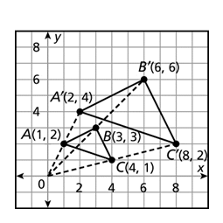

For #2-3, verify whether the two triangles are similar. If they are similar, which theorem would you use to prove it (AA, SAS, SSS)

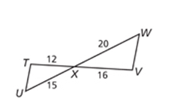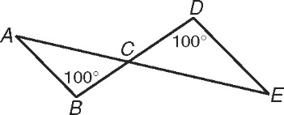2. 3.

