Unit 2 Part 1 Review #2 Name: ______________________ Date: _____________
Standard: Parallel Lines Cut by a Transversal
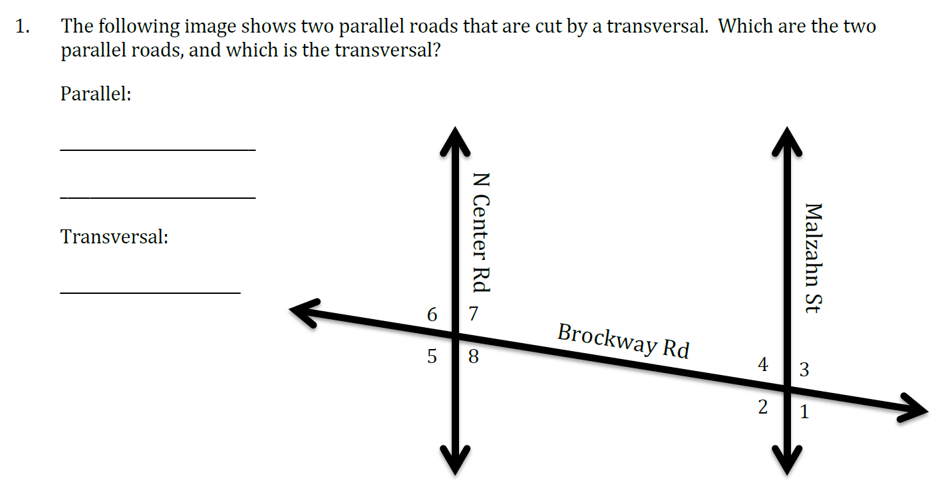
6
8
5
7
Sesame St.
Boyce Rd.
3
1
2
Earle Rd
4
Using the image above, name multiple pairs of each of the following angles.

2. Vertical Angles: $∠______$ and $∠______$ $∠______$ and $∠______$ $∠______$ and $∠______$
3. Corresponding Angles: $∠______$ and $∠______$ $∠______$ and $∠______$ $∠______$ and $∠______$
4. Alternate Exterior Angles: $∠______$ and $∠______$ $∠______$ and $∠______$
5. Linear Pair: $∠______$ and $∠______$ $∠______$ and $∠______$ $∠______$ and $∠______$
6. Same-side Interior Angles: $∠______$ and $∠______$ $∠______$ and $∠______$
7. Same-side Exterior Angles: $∠______$ and $∠______$ $∠______$ and $∠______$
8. Alternate Interior Angles: $∠______$ and $∠______$ $∠______$ and $∠______$
Tell whether each pair of angles are either supplementary or congruent. Circle your answer.

9. Alternate Exterior Angles: supplementary congruent
10. Same-side Interior Angles: supplementary congruent
11. Vertical Angles: supplementary congruent
12. Alternate Interior Angles: supplementary congruent
13. Corresponding Angles: supplementary congruent
14. Linear Pairs: supplementary congruent

15. What does supplementary mean?

16. What does congruent mean?
Find the measure of ALL of the angles given $m∠1=120°$ and$m∠11=45°$.

17. $m∠1$ = _____, $m∠2$ = _____, $m∠3$ = _____,
$m∠4$ = _____, $m∠5$= _____, $m∠6$ = _____, $m∠7$ = _____$,$
$m∠8$ = _____

18. $m∠9$ = _____, $m∠10$ = _____, $m∠11$ = _____,
$m∠12$ = _____, $m∠13$= _____, $m∠14$ = _____,
$m∠15$ = _____$, m∠16$ = _____

Find the measure of ALL of the angles given $m∠2=67°$ and$m∠9=115°$.
18. $m∠1$ = _____, $m∠2$ = _____, $m∠3$ = _____,
16
$m∠4$ = _____, $m∠5$= _____, $m∠6$ = _____, $m∠7$ = _____$,$
$m∠8$ = _____
4
19. $m∠9$ = _____, $m∠10$ = _____, $m∠11$ = _____,
14
10
13
6
$m∠12$ = _____, $m∠13$= _____, $m∠14$ = _____,
$m∠15$ = _____$, m∠16$ = _____

20. Which way is the correct setup?
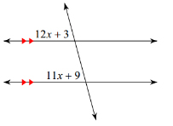
A. 12x + 3 + 11x + 9 = 180
B. 12x + 3 = 11x + 9
C. 12x + 3 + 11x + 9 = 90

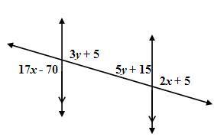
21. Which way is the correct setup for BOTH?
A. 17x – 70 = 2x + 5 and 3y + 5 = 5y + 15
B. 17x – 70 + 2x + 5 = 180 and 3y + 5 = 5y + 15
C. 17x – 70 = 2x + 5 and 3y + 5 + 5y + 15 = 180
C. 17x – 70 + 2x + 5 = 180 and 3y + 5 + 5y + 15 = 180

22. Solve for x and y. 23. Solve for x.
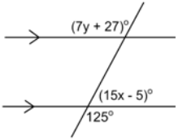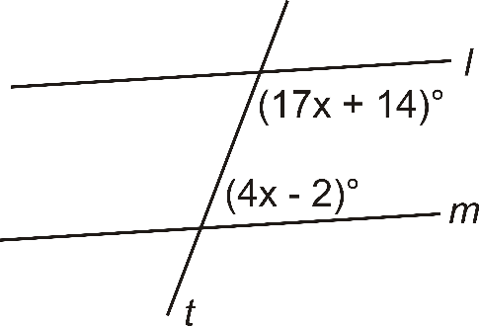

24. Solve for x. 25. Find the measures of Angle 1 and 2.
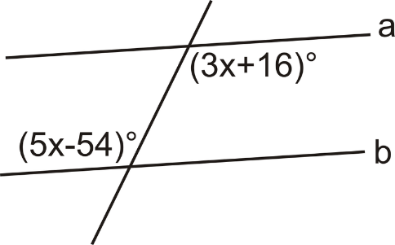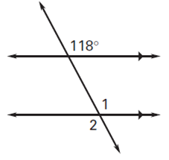

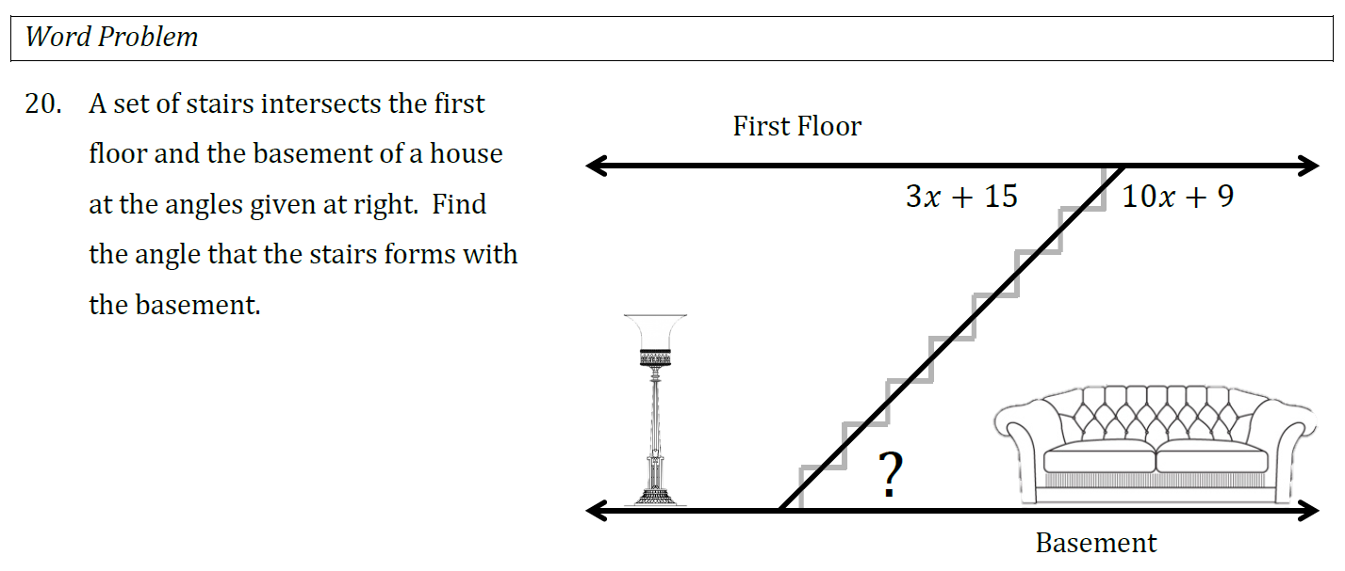
A set of stairs intersects the first floor and the basement of a house at the angles given in the diagram. Find the angle that the stairs forms with the first floor.
?
6x - 42
2x + 14
26.

