Name: __________________________________________________________ Date: ____________________________

Intro to Unit 2 Review Sheet
Standard: Properties of Lines and Angles
Look in your notes to find the definition of the following words:

1. Point

2. Line

3. Ray

4. Line Segment
5. Parallel Lines

6. Perpendicular Lines

7. Midpoint

8. Acute Angle

9. Right Angle

10. Obtuse Angle
11. Angle Bisector
12. Vertical Angle
13. Supplementary Angle
14. Complementary Angle

- Solve for x.  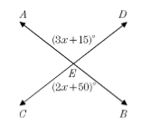 | - Find the$m∠ECB$.  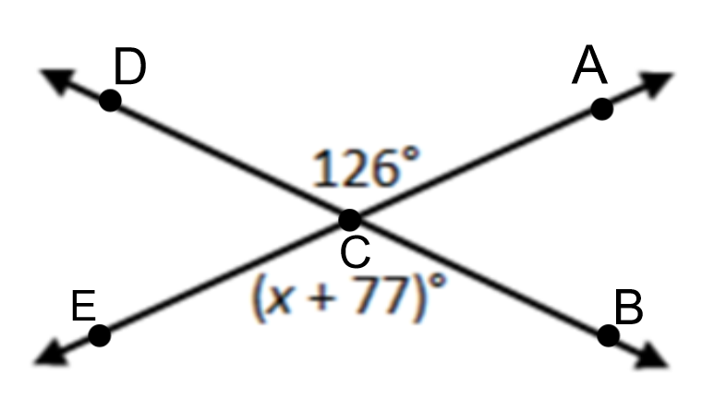
- $∠1$and$∠2$ are complementary angles. If $m∠1=$ 2x + 14 and $m∠2=$ 4x + 46, what is the value of x.  19. $∠1$and$∠2$ are supplementary angles. If $m∠1=$ 3x + 10 and $m∠2=$ 9x + 50, what is the value of x.  21.  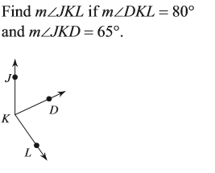  23.  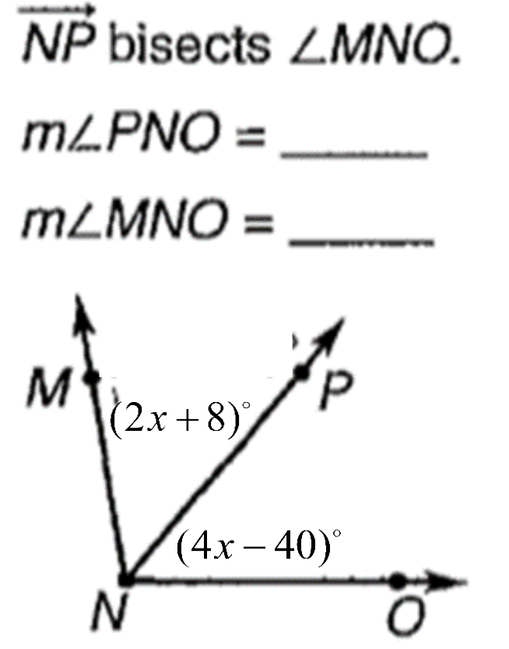18.  For #25-27, Solve for x.  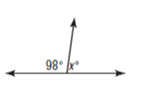  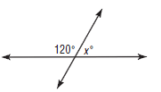  25. 26. | 18. $∠1$and$∠2$ are complementary angles. If $m∠1=$ 2x and $m∠2=$ 8x + 50, what is the value of x.  20. $∠1$and$∠2$ are supplementary angles. If $m∠1=$ 5x and $m∠2=$ 5x + 100, what is the value of x.  22.  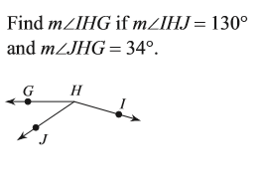  24.  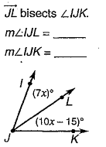  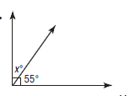  27.

Spiraling
ΔABC has the coordinates A(1, 6), B(2, 2), and C(5, 6).

For each of the following transformations, write the coordinates of the image of ΔA’B’C’. Use the coordinate plane to help you.

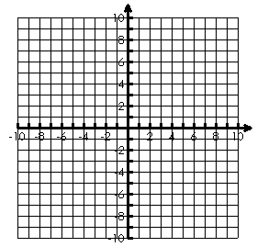
1. Translate 3 right and 4 up.

A’ B’ C’

2. Reflect over the x-axis.

A’ B’ C’

3. Rotate 90° clockwise about the origin.

A’ B’ C’

4. Rotate 180° clockwise about the origin.

A’ B’ C’

