**1.** Write a description of the rule .

**2.** Write a description of the rule .

**3.** Point *A* (–1, –5) is rotated 90° counterclockwise about the origin. What is the coordinates of *A’*.

**4.** Point *B* (3, 4) is rotated 270° counterclockwise about the origin. What is the coordinates of *B’*.

**5.** Point *C* (–2, 6) is rotated 90° clockwise about the origin. What is the coordinates of *C’*.

**6.** Point *D* (5, -8) is rotated 270° clockwise about the origin. What is the coordinates of *D’*.

**7.** Point *E* (-1, 4) is rotated 180° about the origin, what is the coordinate of *E’*?

**8.** Which of the following transformations that we have learned result in congruent figures and which one results in a similar figure?

**9.** Sketch the graph of after a reflection over the y-axis?



**10.** Sketch the graph of after a reflection over the x-axis?



**11.** Sketch the graph of after a reflection over the line y = -2. What are the new coordinates of K`?



12. Using the graph below:

a. write a rule for a translation from point *F* to point *B*?

b. write a rule for a translation from point A to point E?

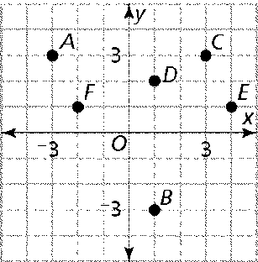

**13.** Point *X* (-1, -3) is translated using the rule , then reflected over the *y*-axis.What is the coordinate of *X”*?

**14.** Point *A* (-1, -3) is translated using the rule , then reflected over the *x*-axis.What is the coordinate of *A”*?

**15.** A rectangle is plotted on the coordinate plane.



Name the degrees and direction of each prime picture below. The above picture is the original.

 **(a)** **(b)** (c) (d)



**16.** What is the scale factor used to go from P(3, -7) to P’(9, -21)?

**17.** What is the scale factor used to go from A(3, -12) to A’(1, -4)?

**18.** If the result of (x, y)→(x – 1, y + 2) is A’(-3, 7), what is the pre-image (original), A?

**19.** If the result of (x, y)→(x + 2, y - 5) is A’(2, -3), what is the pre-image (original), A?

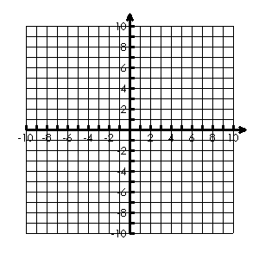**20.** If P(-6, 3) is reflected over the line y = 2 and then translated according to the rule (x, y)→(x +1, y – 4), what quadrant will P’’ be in?

**21.** 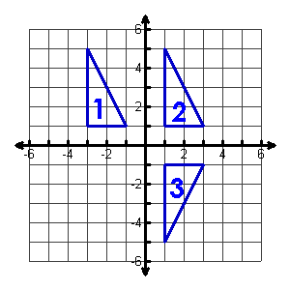Triangle 1 is transformed as shown in the diagram, resulting in Triangle 2. Triangle 2 is transformed to create Triangle 3. Describe the combination of transformations (1→2→3).

**22.** If ∆MTV is reflected across the x-axis, what is the resulting coordinates?

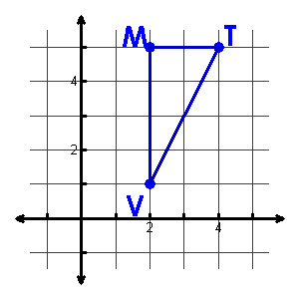

**23**. Describe the dilation of quadrilateral MNOP.

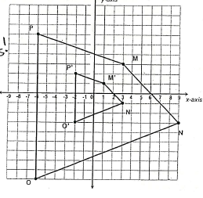a. Is this a reduction or enlargement?

b. What is the scale factor?

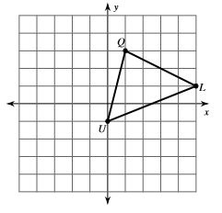**24**. Translate the figure by (x – 1, y - 3)

Q ( ) Q` ( )

U ( ) U` ( )

L ( ) L` ( )

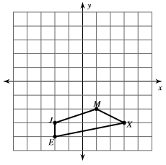**25**. Translate the figure by (x + 1, y + 5)

J ( ) J` ( )

E( ) E` ( )

M ( ) M` ( )

X ( ) X` ( )

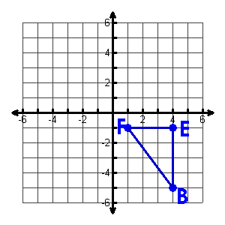**26**. Reflect the figure over the line .



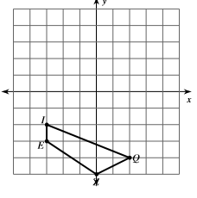**27**. Reflect the figure over the line y = -2.

I ( ) I` ( )

E( ) E` ( )

Q ( ) Q` ( )

Z ( ) Z` ( )

**28**. Rotate 270° counterclockwise around the origin

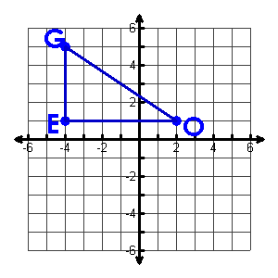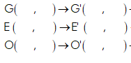

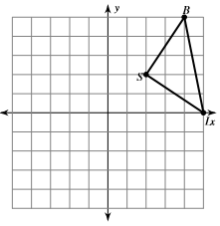**29.** Rotate 90° counterclockwise around the origin

I ( ) I` ( )

S( ) S` ( )

B ( ) B` ( )

**30**. On the grid below, draw the image of  after a dilation with a scale factor of  and list the new ordered pairs.

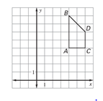

What will be the coordinates of point *A”* after a translation of polygon *A’B’C’D’* three units to the left and two units up?

**31. Triangle W(-1, 6), H(-3, -2), S(6, 5) maps to W’(-1, -6), H’(-3, 2), S’(6, -5).**

1. ****What transformation has taken place?
2. Write the function/rule for the transformation.