Geometry YL Name _________________

Review Sheet

Circles Vocab, Tangent Theorems, Central Angles, Minor/Major Arcs

Part I Use the diagram at the right and match the term with the notation that best

describes it. Each answer can only be used once.

|  |  |  |
| --- | --- | --- |
| _____1. Center  _____2. Chord  _____3. Common Internal Tangent  _____4. Minor Arc  _____5. Diameter  _____6. Point of Tangency  _____7. Common External Tangent  _____8. Radius  _____9. Secant  _____10. Major Arc | A)  B)  C)  D)  E)  F)  G)  H) W I)  J)  K) R L) |  |

Part II Solve for each variable. In the drawings, if it looks like a tangent it is a tangent.

11. x = ________ 12. x = ________ 13. x = ________

36

51

x

5x - 14

3x + 52

8x - 23

3x + 52

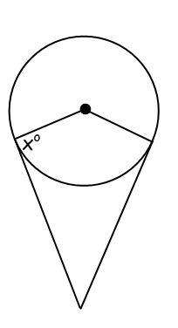14. x = ________ 15. x = ________ 16. x = ________

84

8 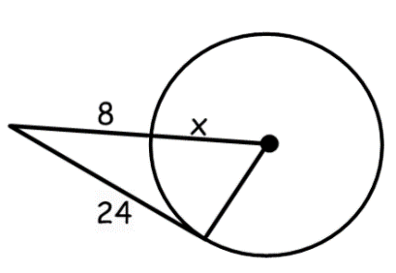

x

32

103

x

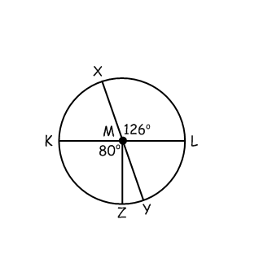

Use the picture below for #17-23. Find the measure of each angle or arc.  and are diameters.

17.  18. 

19.  20. 

21.  22. 

23. 

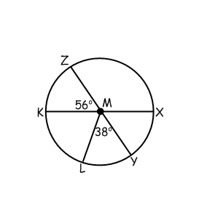**Use the picture below for #24-30. Find the measure of each angle or arc. and** **are diameters.**

24.  25. 

26.  27. 

28.  29. 

30. 

Spiraling

Standard: Right Triangle Trig

1. Triangle DEF is a right triangle. What is the measure of <C? What is the measure of <A?

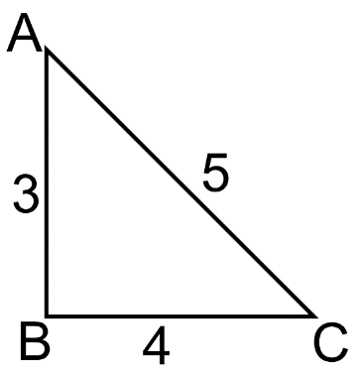

2. In the triangle to the right, . Find sin A.

A

C

B

3. What is an equivalent trig ratio for tan 28?

4. What is an equivalent trig ratio for sin 20˚?

5. What is an equivalent trig ratio for cos 57˚

.

6. A 15 foot ladder is leaning against a building at a 65˚ angle with the ground. Write an equation that could be used to solve for how high the ladder reaches up the side of the building.

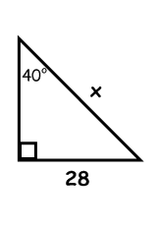 For #7-8, solve for the missing side. 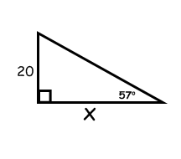

7. 8.