CCGPS Analytic Geometry with Support Name \_\_\_\_\_\_\_\_\_\_\_\_\_\_\_\_\_\_\_\_\_\_\_\_\_\_\_\_\_\_\_\_\_\_

Review Sheet: Unit 2 Part 5 Similarity

Standard: Similarity

1. Find x 2. Find CY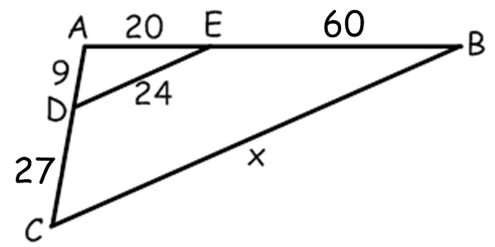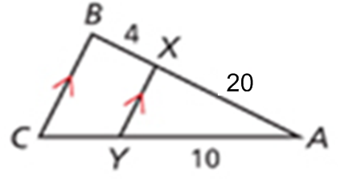

3. Find x 4. Is TU parallel to RS? **SHOW YOUR WORK!**

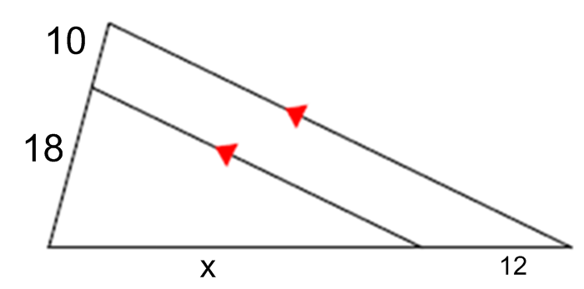 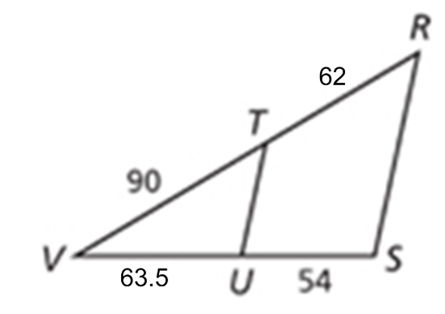

5. Is MN parallel to PQ? **SHOW YOUR WORK!**

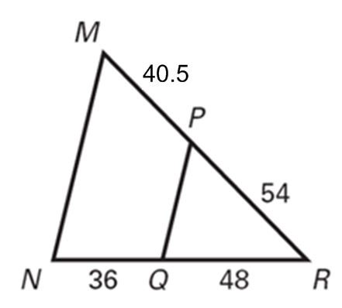

6. What is the scale factor from ABC to A’B’C’?

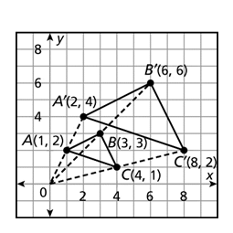

7. What is the scale factor from PQR to P’Q’R’?

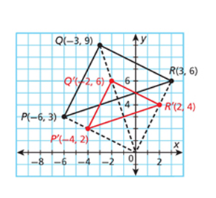

|  |  |  |  |  |  |
| --- | --- | --- | --- | --- | --- |
| 8. | Are the two triangles similar? If so, by what method? | | |  | |
|  | | | | | |
|  |  |  |  | |  |
|  |  |  |  | |  |

|  |  |  |  |  |  |  |  |  |
| --- | --- | --- | --- | --- | --- | --- | --- | --- |
| 9. | Verify the triangles are similar (AA, SSS or SAS) and write the similarity statement. | | | | | 10  20  25  8 | | |
|  | | | | | | | | |
|  |  |  | | |  | | |  |
|  |  |  | | |  | | |  |
| 10. | Assuming the two triangles are similar, find the tower's height from the given measurements below. | | |  | | | | |
|  |  |  |  | | | |  | |
|  |  |  |  | | | |  | |
|  |  |  |  | | | |  | |

|  |  |  |  |  |  |  |
| --- | --- | --- | --- | --- | --- | --- |
| 11. | Given:  Find the scale factor fromand find the coordinates for D. | | | |  | |
|  | | | | | | |
|  |  | | |  |  |  |
| 12. |  | | |  |  |  |
|  |  | | | |  | |
| 13. | Figure ***A’B’C’*** is a dilation of figure ***ABC***. Find the scale factor from ***ABC to A’B’C’*** | | |  | | |
|  | | | | | | |
|  |  |  |  |  | | |
|  |  |  |  |  | | |

In # 14-17, Determine if each pair of triangles are similar. If they are not similar, WRITE NOT SIMILAR. If you determine they are similar, explain how you know **(show your work!)**

|  |  |
| --- | --- |
| 14.  Go07an_0703praB_01 | 15.  Go07an_0703praA_01 |
| 16. | 17. |

Find the value of x given that the triangles are similar.

18.  19. 

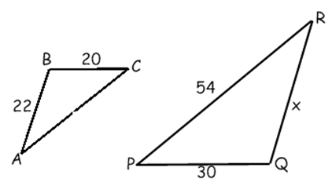 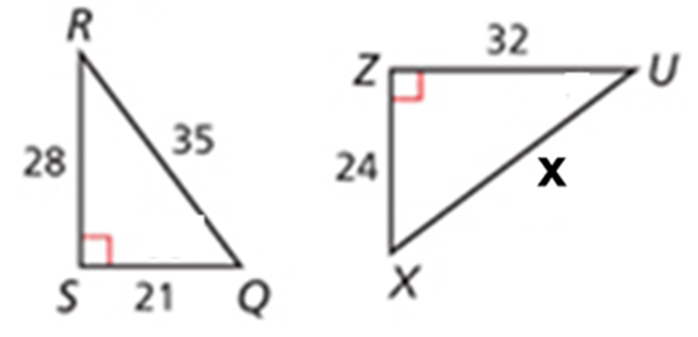

10.7

8

27 7

12

16

18

15

20. 21.

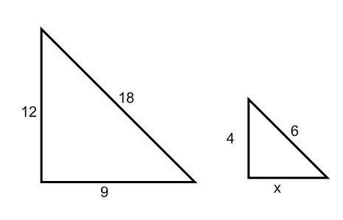 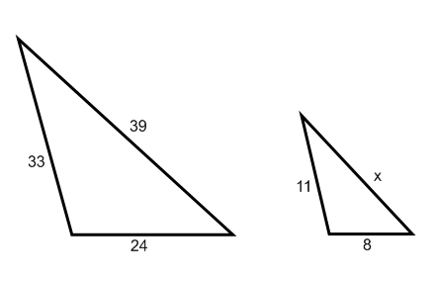

**Directions:** Use ∆ABC, where L, M, and N are midpoints of the sides.

**22)** LM\_\_\_\_\_\_\_

B

C

M

A

N

L

**23)** AB\_\_\_\_\_\_\_

**24)** If *AC* = 30, then *LN = \_\_\_\_\_\_\_*

**25)** If *MN* = 11, then *AB = \_\_\_\_\_\_\_*

**26)** If *NC* =5 , then *LM = \_\_\_\_\_\_\_*

**27)** If *LM* = 2x+3, and *BC =* 6x + 2, then  *LM = \_\_*

**28)** If LN=9, NM=13 and LM=20, find the perimeter of ∆ABC \_\_\_\_\_\_\_\_\_\_\_\_\_\_\_\_\_\_\_\_\_\_\_\_\_\_\_\_\_\_\_