Unit 2 Part 4 Review on Quads Name: ________________________________

1. The figure is a parallelogram. Solve for HN. 2. PQRS is a rectangle. Solve for x.

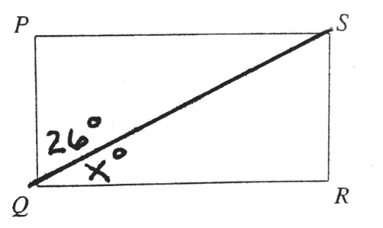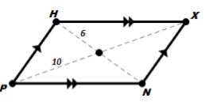

3. The figure is a parallelogram. Solve for the variables. 4. The figure is a parallelogram. Solve for the variables.

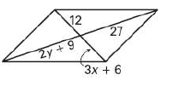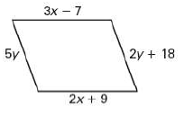

5. Solve for the variables. 6. The figure is a parallelogram.

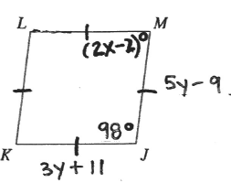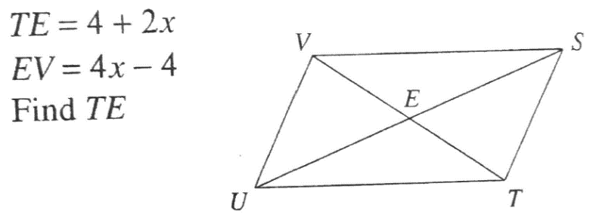

7.

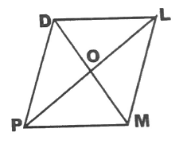

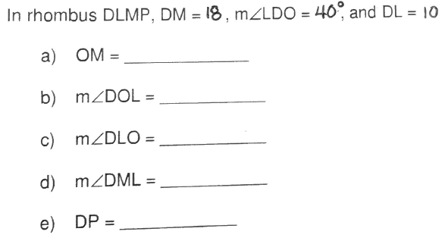

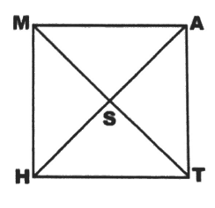8.

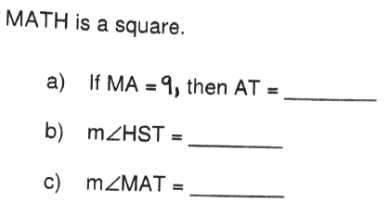

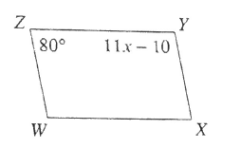9. WXYZ is a parallelogram. Solve for x. 10. RSTU is a parallelogram. Solve for TS.

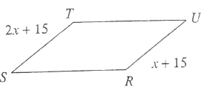

11. UVWX is a parallelogram. Solve for <W. 12. STUV is a parallelogram. Solve for x.

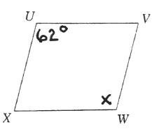

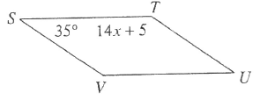

13. Give the best name (parallelogram, rectangle, rhombus, or square) for the quadrilateral with the given information.

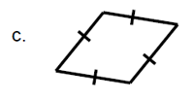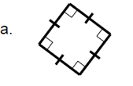

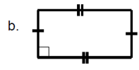

Spiraling

Standard: Triangle Congruence

I. State if the two triangles are congruent. If they are, state whether it is SSS, SAS, ASA, AAS, or HL.

|  |  |
| --- | --- |
| 14.  Related image | 15.    17. |
|  |
|  |
| 16.  Image result for congruent triangle HL |

**18.**

**9.** 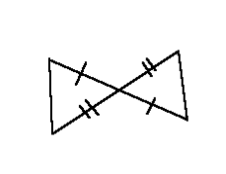

|  |
| --- |
| 19. **Given**: $∠A≅∠E$ and $\overline{AC}≅\overline{EF}$ What OTHER piece of information is needed to show $∆ABC≅∆EDF$ by AAS? |
| 20. **Given**: Q is the midpoint of $\overline{PS}$ and $∠R≅∠T$. How could your prove $∆PQR≅∆SQT?$   **21.** Given: $\overline{AB}≅\overline{CD}$ and $\overline{AD}≅\overline{CB}$ Prove:   |  |  | | --- | --- | | **Statements** | **Reasons** | |  | 1. Given | |  |  | |  |  | |  | 1. SSS | |  |  |     **22**. Given: M is the midpoint of $\overline{PN}$ and <P $≅$ <N  Prove:   |  |  | | --- | --- | | **Statements** | **Reasons** | | 1. M is the midpoint of |  | |  | 1. Given | |  |  | |  | 1. Vertical Angles | |  |  | |