Statistical Reasoning Unit 1 Review Sheet Name: ______________________
Unit 1A: Characteristics & Properties of Angles
Topic: Types of Studies | Things to Remember:  - Observational Study – Gathering information by OBSERVING, but effecting the outcome  - Experimental Study – Gathering information by using a TREATMENT  - Sample Survey – Gathering information by ASKING people’s opinions
Examples:
1. Xevier wonders about the effects of listening to classical music while studying. He randomly assigns students to listen to classical music while they study and another group to study in a quiet room. What type of study is he performing? | 2. Kayla wonders if athletes perform better in Math or Language Arts classes. She recruits 50 athletes from her school to take a basic test in each subject and compares results. What type of study is she performing?
3. Hunter wonders what cafeteria food high school students prefer. He goes around the lunch room during all 4 lunch periods and randomly asks 50 students in each what their preference is. What type of study is he performing? | 4. Mrs. Brattebo wants to know if her dogs would bark less if they are placed in their kennels. One night she lets them stay out of the kennel and counts how many times her dogs bark that night. The next night, she places her dogs in their kennels and counts how many times her dogs bark. She compares the number of times the dogs bark from both nights.
Topic: Vocabulary | Things to Remember:  - Individuals – The objects described by a set of data  - Variables – Any characteristic of an individual  - Quantitative – Variable that takes a numerical value and averaging makes sense  - Categorical – Variable that places an individual into one of several groups or categories  - Population – The entire group of individuals that we want to study  - Sample – A part of the population  - Census – A sample survey that attempts to include the ENTIRE population in the sample
Examples:
On the first day of school, Ms. Brattebo asked her 32 students various questions.
5. What were the individuals in this SURVEY? | 6. What was the sample in the SURVEY?
7. List 4 possible questions she could have asked that would yield quantitative variables.  1.  2.  3.  4. | 8. List 4 possible questions she could have asked that would yield categorical data.  1.  2.  3.  4.
9. What’s the difference between a population and a sample? | 10. Would it make sense to do a census to ask ALL the students at Wheeler High School their favorite color? Why or why not?

Topic: Statistical Problem-Solving Process | Things to Remember:  MAKE SURE THIS PROCESS IS IN ORDER!!
Examples:
11. What are the 4 steps of the statistical problem-solving process?

12. Psychologists designed a study involving 47 creative writers. Students were divided into two groups. The students in one group were given a list of statements about external reasons for writing, like public recognition, making money, or pleasing their parents. Students in the other group were given a list of statements about internal reasons for writing, such as expressing yourself and enjoying working with words. Both groups were then instructed to write a poem that would be rated.

a) What was the sample?

b) State a question of interest that can be answered using the dot plot.

c) What type of study was this?

Here’s the data collected during this study:

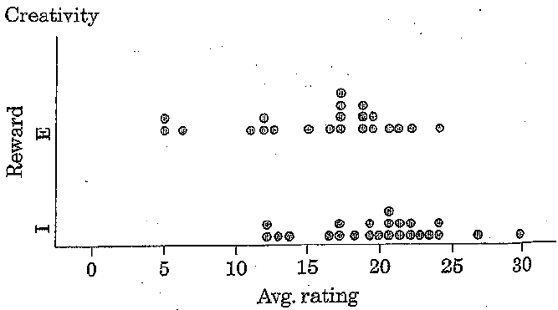

c) Analyze the data (what do you notice?):

d) Interpret the results (draw a conclusion):

