Name: ___________________________________ Date: _____________ Block: _______
The Great M&M Experiment
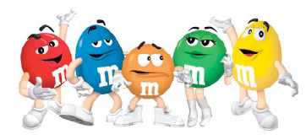
QUESTION: What percentage of milk chocolate M&M candies are orange?
The purpose of this activity is to introduce you to the basic concepts we will be encountering in Statistical Reasoning. Your goal is to answer the question above using only a “Sample” of M&M candies. You must justify your conclusion by organizing, plotting, and referencing data collected by the entire class.
I. Collecting the Data:
Scoop out a sample of M&M candies. Count the total number of M&Ms in your sample. You will need EXACTLY 25 M&Ms, so if you need more, RANDOMLY choose a few more to add to your sample. If you have too many, you must RANDOMLY choose M&Ms to discard. DO THIS WITHOUT LOOKING SO THAT IT IS RANDOM! NO PEEKING!
II. Organizing the Data
Calculate the percentage of each of the colors in your sample using the table below.
Color | Percentage | Color | Percentage
Blue |  | Brown
Green |  | Orange
Red |  | Yellow

a. Write the percentage of orange M&Ms in your sample: ___________
b. Record the class data using the following chart:
Group # | Percentage of Orange Candies | Group # | Percentage of Orange Candies
1 |  | 9
2 |  | 10
3 |  | 11
4 |  | 12
5 |  | 13
6 |  | 14
7 |  | 15
8 |  | 16

III. Displaying the Data: Display the data using a dot plot.
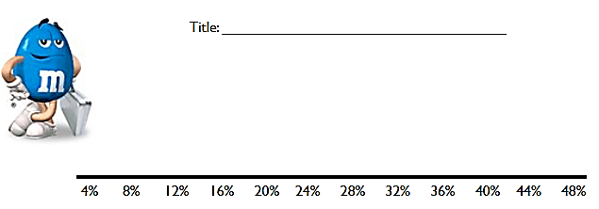

IV. Analyzing the Data:
  - Describe some general features of the data.

  - What would you consider a “normal” or a “typical” percentage of orange M&Ms? Why?

  - Does our data reveal the true percentage of orange M&Ms?

If so, what is the true percentage?

If not, what DOES it reveal about the true percentage?

CONCLUSION: How confident are you in your conclusion? Why?

