GSE Geometry with Support Name: ___________________________
Translations – Choose 9 problems to complete
1. Find the coordinates of the image left 2 and up 4  A(-3, 3)  B(-3, 4)  C(1, 2) | 2. Find the coordinates of the image using the rule: (x, y) (x + 3, y – 1)  A(0, 4)  B(4, 5)  C(1, 1) | 3. Explain what the following rule means in words:  (x, y) (x + 1, y – 8)
4. Find the coordinates of the image right 2  A(-2, 3)  B(-3, 0)  C(1, -2) | 5. Write the general rule using the image and pre-image’s coordinates  _____________________________  A(0, -4) A’(-2, -2)  B(4, 2) B’(2, 4)  C(1, 0) C’(-1, 2) | 6. Write the general rule of the following translation.  _____________________________  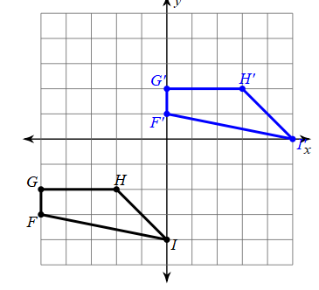
7. Write the general rule of the following translation.  _____________________________  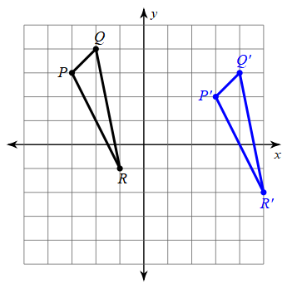 | 8. Write the general rule of the following translation.  _____________________________  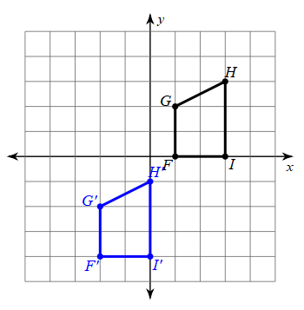 | 9. Write the general rule of the following translation.  __________________________  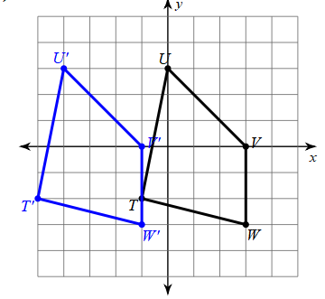
10. Graph the translation using the rule (x, y) (x, y – 5)  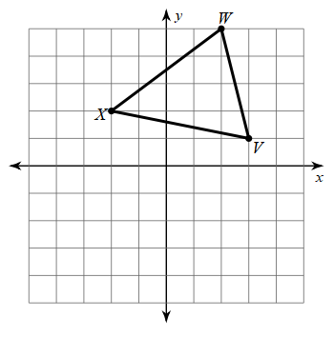 | 11. Graph the translation using the rule (x, y) (x + 3, y – 4)  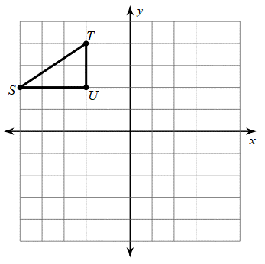 | 12. Graph a translation 4 units right.  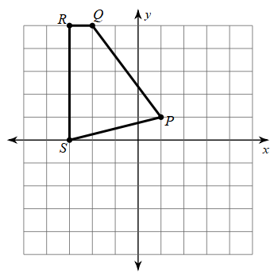
Reflections – Choose 9 problems to complete
1. Find the coordinates of the image reflected over the x-axis  A(-3, 3)  B(-3, 4)  C(1, 2) | 2. Find the coordinates of the image using the rule: (x, y) (-x, y)  A(0, 4)  B(4, 5)  C(1, 1) | 3. Explain what the following rule means in words:  (x, y) (x, -y)
4. Find the coordinates of the image reflected over the y-axis  A(-2, 3)  B(-3, 0)  C(1, -2) | 5. Write the general rule using the image and pre-image’s coordinates  _____________________________  A(0, -4) A’(0, 4)  B(4, 2) B’(4, -2)  C(1, 0) C’(1, 0) | 6. Write the line of reflection that was used.  _____________________________  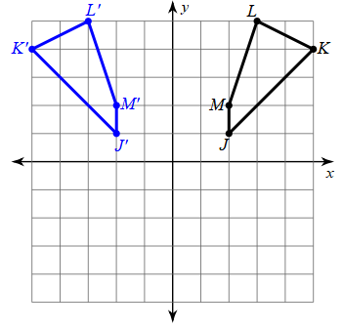
7. Reflect over the x = 1  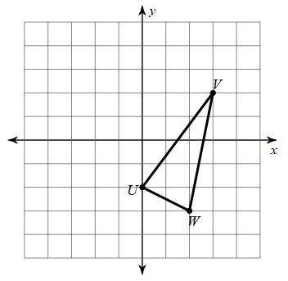 | 8. Write the line of reflection that was used.  _____________________________  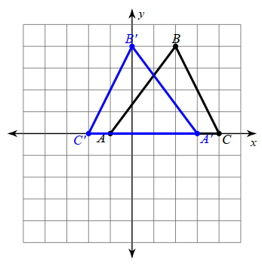 | 9. Write the line of reflection that was used.  __________________________  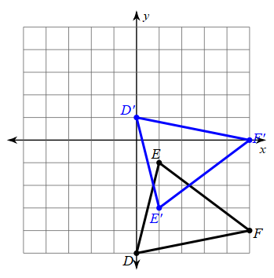
10. Reflect over y = -1  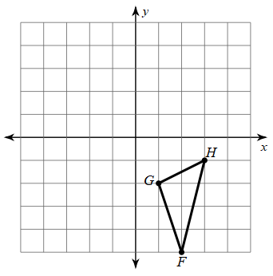 | 11. Reflect over the x-axis | 12. Reflect over x = -2

