Construct a histogram and describe the shape.
Score | Frequency
30 to $<$ 40 | 5
 | 4
 | 5
 | 2
 | 6
 | 1
 | 3
Test scores of students in a science class.
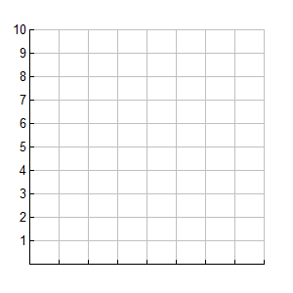
74, 96, 47, 63, 68, 72, 98, 78, 89, 87, 63, 61, 70, 80, 99, 90, 34, 41, 80, 91, 40

SHAPE:

Average hours worked per week in 1st Block Statistics
35, 20, 32, 21, 27, 0, 30, 40, 0, 30, 15, 17, 28, 25, 45, 27, 10, 41, 35, 21, 32

SHAPE:

