Guided Notes
Parallelograms – Fill in the blanks with the appropriate measures for the parallelogram. Label all segments and angles in your picture to help you.
Properties of Parallelograms and Misc.:
Opposite SIDES are congruent | Opposite ANGLES are congruent | Consecutive ANGLES are supplementary
Diagonals BISECT each other | REMEMBER:  - Alternate Interior ANGLES are congruent  - TRIANGLES add up to 180º  - QUADRILATERALS add up to 360º
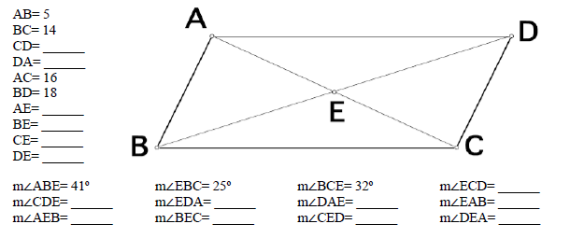
Rectangles – Fill in the blanks with the appropriate measures for the rectangle. Label all segments and angles in your picture to help you.
Properties of Rectangles and Misc.:
Opposite SIDES are congruent | ALL ANGLES are congruent (90º) | Consecutive ANGLES are supplementary
Diagonals BISECT each other  Diagonals are congruent | REMEMBER:  - Alternate Interior ANGLES are congruent  - TRIANGLES add up to 180º  - QUADRILATERALS add up to 360º
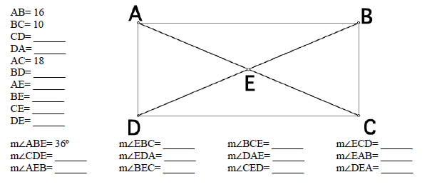
Rhombus – Fill in the blanks with the appropriate measures for the rhombus. Label all segments and angles in your picture to help you.
Properties of Rhombi and Misc.:
ALL SIDES are congruent | Opposite ANGLES are congruent | Consecutive ANGLES are supplementary
Diagonals BISECT each other and opposite angles  Diagonals are perpendicular | REMEMBER:  - Alternate Interior ANGLES are congruent  - TRIANGLES add up to 180º  - QUADRILATERALS add up to 360º
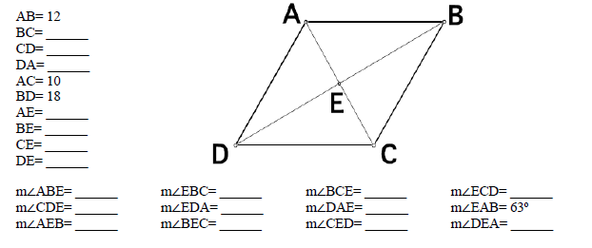
Square – Fill in the blanks with the appropriate measures for the square. Label all segments and angles in your picture to help you.
Properties of Squares and Misc.:
ALL SIDES are congruent | ALL ANGLES are congruent (90º) | Consecutive ANGLES are supplementary
Diagonals BISECT each other and opposite angles  Diagonals are perpendicular  Diagonals are congruent | REMEMBER:  - Alternate Interior ANGLES are congruent  - TRIANGLES add up to 180º  - QUADRILATERALS add up to 360º

