Name: ________________________________ Date: _________________ Unit 2C Quiz Practice
I. Triangle Proportionality
1. Solve for the missing length.  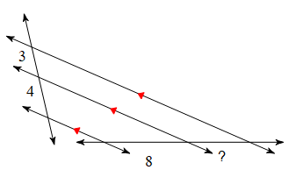 | 2. Find the missing length.  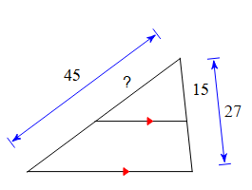
3. Determine if $\overline{EF}$ is parallel to $\overline{QR}$  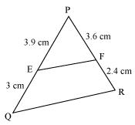 | 4. Determine if $\overline{AB}$ is parallel to $\overline{CD}$  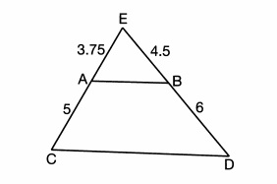
II. Dilations and Scale Factor
- Graph the new image using the rule  $\left(x,y\right)→(\frac{3}{2}x,\frac{3}{2}y)$ and centered at the origin.  - What type of dilation was performed?  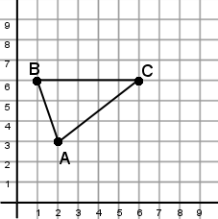 | 6.  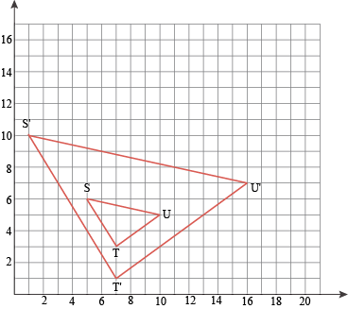  - Find the center of dilation.  - Calculate the scale factor.
7.  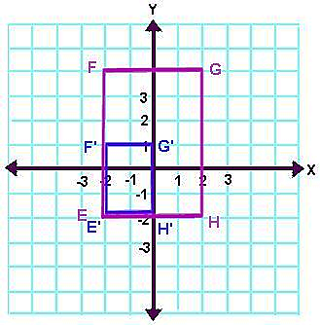  - Find the center of dilation.  - Calculate the scale factor. | 8.  a. How does perimeter change with scale factor?  b. How does area change with scale factor?  III. Similar Figures  9. Solve for ED.  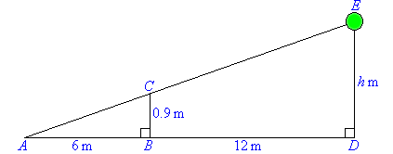
10. What two properties must similar figures have? (HINT: something about the sides AND angles) |  | 11. Shawn looked at a map and saw a scale of 1 in: 3 miles. The city of Kennesaw was 3 inches from Marietta. How far away is Kennesaw from Marietta?
IV. Proving Similar Triangles

12. What are the only ways triangles can be similar?

a) State if the triangles are similar or not. B) If they are similar, complete a similarity statement.
13.  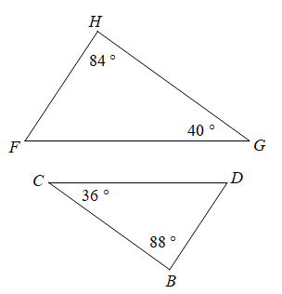 |  | 14.  