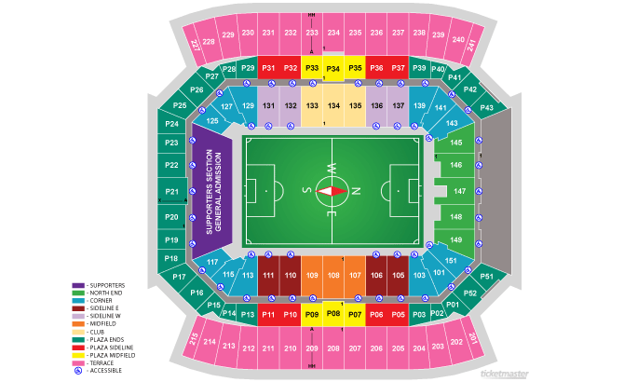
Is there any relationship between the price of the ticket and the distance from the soccer field? Assume I am going to get a seat right at the half-way line (centered) and that row 1 is close to the field and row 50 is further away up in the stands.
Row # | Price
2 | $205
8 | $175
10 | $170
15 | $105
20 | $185
25 | $100
30 | $65
32 | $78
40 | $50
48 | $20

- Would it be appropriate to assign one variable as explanatory and the other as response, or is this just a relationship between two variables? How do you know?

- Make a scatterplot of the data.

- The correlation coefficient is: . Describe what this means in this situation.

- The line of best fit is:

- What does the slope (a) mean in this situation?

- What does the y-intercept (b) mean in this situation?

- What would you predict the cost of a seat on the 21st row? 37th row?

- If your seat cost $127, what row would you expect to sit in?

- What would happen to the correlation if you measured cost in euros instead of dollars?

- Use residuals to determine if the equation you wrote in Question #3 is a good fit for the data.
x | Equation | Actual Y | Predicted Y | Residual
2
8
10
15
20
25
30
32
40
48

- Using the residual data, do you think that the line is a good fit or not. Explain.

- A residual is the difference between a piece of data (observed value) and the regression equation (predicted value). What do you think the amount of error means in terms of price vs seat at the stadium?

- What is the value for R²? Explain what this number tells us about the regression line.

