Name: ________________________________ Date: _________________ Unit 3 Quiz Practice
I. Pythagorean Theorem
1. Find the missing side. | 2. In a right triangle, the length of a hypotenuse is 19 and the length of one leg is $\sqrt{5}.$ What is the length of the other leg is?
II. Trig Ratios
3.  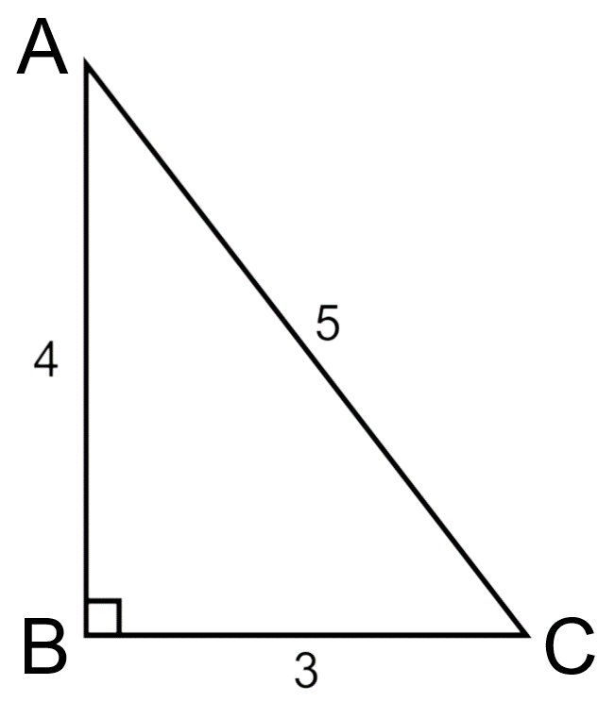  a. Write all 3 trig ratios for Angle A.  b. Write all 3 trig ratios for Angle C. | 4.  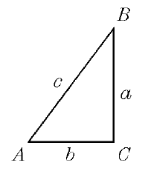  a. Write all 3 trig ratios for Angle A (use the variables).  b. Write all 3 trig ratios for Angle B (use the variables).
5. Write an equivalent co-function for the following functions below:  a. sin(30)  b. cos(70)  c. tan(20)  d. sin(56)  7. If the$\tan\left(θ\right)=\frac{1}{3}$, find the$\sin\left(θ\right)$. | 6. If the$\cos\left(θ\right)=\frac{8}{\sqrt{140}}$, find the$\tan\left(θ\right)$.  8. If the$\sin\left(θ\right)=\frac{\sqrt{7}}{4}$, find the$\cos\left(θ\right)$.
III. Using Trig Ratios

Use the correct trig ratio to solve for a side or an angle.

9.  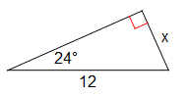 |  | 10.  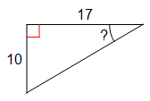
11. Solve for Angle A.  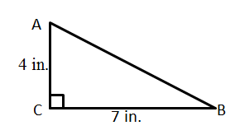 |  | 12. If BA = 12, $∠C=52°$, what is side CA?  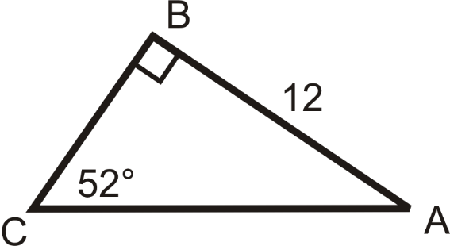
13. If the tree is 100 ft tall and the person is 50 ft away from the base of the tree, what is the angle of elevation?  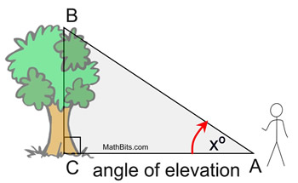 |  | 14. How high is the kite from the ground?  