Name: __________________________________ Date: ________________ Block: ___________
Unit 2A Quiz 1 Review
Write the definitions for the following vocabulary.

- Scalene Triangle

- Equilateral Triangle

- Isosceles Triangle

- Triangle Sum Theorem

- Exterior Sum Theorem

- Solve for x.  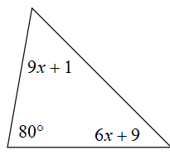 | - Solve for x.  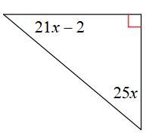
- Solve for x.  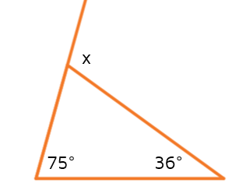 | - Solve for x.  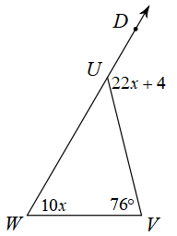
- Solve for x.  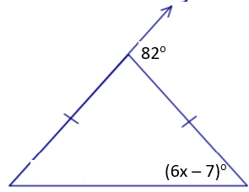 | - Solve for x  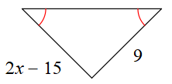
Use the diagram to answer questions #12-18.

$m∠1=100°$ and $m∠6=139°$
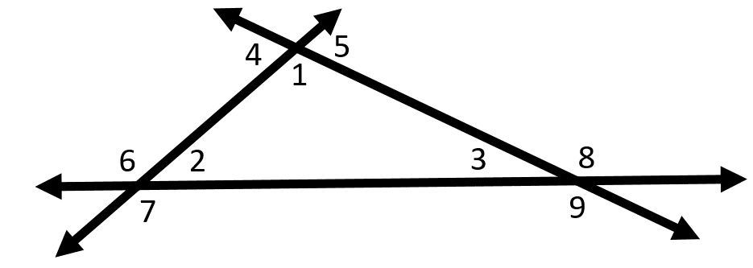
- ______ $m∠2$
- ______ $m∠3$
- ______ $m∠4$
- ______ $m∠5$
- ______ $m∠7$
- ______ $m∠8$
- ______ $m∠9$

19. Prove $∆ABC$ is a scalene triangle.
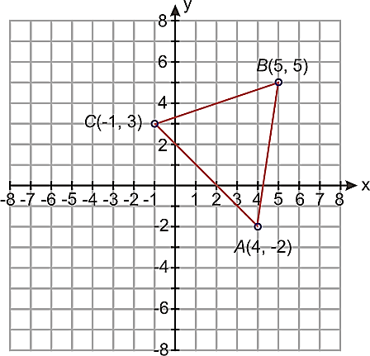

20. What is ONE coordinate for C that would complete the triangle as a right triangle?
