Unit 4C Review Name: _______________ Date: _______
1. What shape would roughly model a bowl of cereal?

2. Find the volume of the silo.
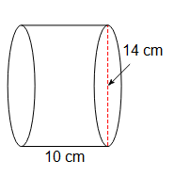
Find the volume of the following below:
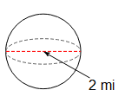
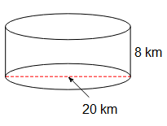
3. 4. 5.

6. Calculate the volume of the model barn.
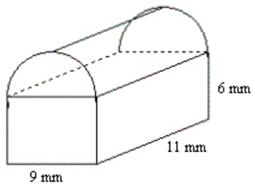
4 mm

7. A crystal ball is placed inside a cylindrical container with foam so it doesn’t break. The radius of the crystal ball is 3.5 inches. How much cubic inches of foam is required to fill the rest of the container?

8. The park rangers in California built the following chart for their rectangular forest that is 50 miles by 80 miles. (HINT: Find the area first)

Elk Population Density | Number of Allowed Kills
< 1.89 | 0
1.9 < x < 2.9 | 1
3 < x < 4 | 2
4.1 < x < 5.1 | 3

A. How many kills will be allowed if there are 1700 elk?

B. How many kills will be allowed if there are 17000 elk?

C. How many kills will be allowed if there are 7000 elk?
9. Three ping pong balls with an 1 inch diameter are sold in cylindrical cans of five. How much space is not occupied by the ping pong balls in the can?

10. The population in Quebec is 8,430,000 people and has an area of 595,000 square miles. The population in California is 39,540,000 people and has an area of 163,696 square miles.

A. What is the population density of Quebec?

B. What is the population density of California?

C. How many times larger is the population density of California compared to Quebec?

